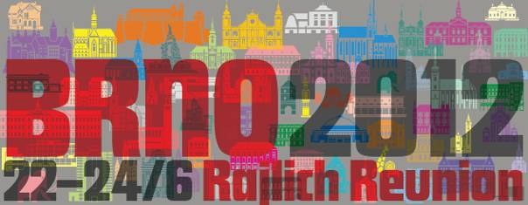

Dear members of the Rajlichs / Reilichs family, dear friends,

It is just three years ago we met at the Dírná village in Southern Bohemia at the 4th Rajlich´s family Reunion. Let us to inform you, that the 5th Reunion is being prepared. It will be organized this time at city of Brno in Southern Moravia (the Czech Republic) on weekend from the 22nd to the 24th June, 2012. Accommodation: at a students dormitory in the Brno suburb called Komin, where the conference room will be at our disposal as well; meals will be taken in the same place.

Be kind enough, and take a note of the date of the Reunion. Consider, please, this advice as a preliminary one only. More detailed information will be send to you as soon as possible.

For both information and preliminary interest of your participation call kindly
+420 541 223 211, or +420 602 766 491 (cell), e-mail: rajlich.jk@seznam.cz, or
+420 541 142 544, or +420 549 252 807, e-mail rajlich@fme.vutbr.cz

With the best regards, Yours sincerely

-- Mr. Jaroslav Rajlich, 49 Absolonova Str., 624 00 Brno-Komín, Czech Republic
-- Mr. Jan Rajlich, jr., 4 Jiráskova Str., 602 00 Brno, Czech Republic

on behalf of the Reunion organizers

Information will follow also at:
http://www.rajlich.cz/aktuality.html

